**Multiple Disease Prediction: An AI and ML Based System**

**Author,**

*Raghav Aswal*

*Department of Computer Science and Engineering*

*Graphic Era Hill University*

*Dehradun, Uttarakhand*

*India.*

[*raghav06aswal@gmail.com*](mailto:raghav06aswal@gmail.com)

|  |  |
| --- | --- |
| **Abstract**  In recent years, the application of Machine Learning (ML) techniques to healthcare has gained substantial attention due to its potential to predict multiple diseases accurately and in real time. Early detection of diseases such as diabetes, heart disease, Parkinson’s disease, and others can significantly reduce mortality rates and healthcare costs. This paper explores the use of machine learning algorithms to predict various diseases based on patient data. We discuss different types of machine learning models, their effectiveness in disease prediction, the challenges involved, and future directions for research. Using a multi-disease prediction system can enable early diagnosis, improve treatment outcomes, and streamline medical decision-making. The rapid advancement of machine learning (ML) technologies has opened new frontiers in healthcare, particularly in the prediction and early detection of diseases. Traditional methods of disease diagnosis often rely on subjective clinical evaluations and time-consuming tests. In contrast, ML models, by analysing large volumes of patient data, can offer more timely, accurate, and cost-effective predictions. | We explore various machine learning algorithms such as supervised learning (logistic regression, decision trees, support vector machines).  ***Keywords:*** *Machine Learning, Artificial Intelligence,*  *Disease Detection, HealthCare, Multiple Disease Prediction, Supervised Learning.*  **1. Introduction**  The healthcare industry has experienced the most significant shift towards digital transformation with the widespread adoption of advanced technologies such as ML and AI. These technologies are revolutionizing the ability to predict, diagnose, and treat various diseases by providing healthcare providers with robust tools for analysing patient data. Disease prediction is critical to modern healthcare in that often, the earlier the detection, the better the treatment and lower the cost. |

**Health Disease fatality rate per 1000 000 population by WHO**

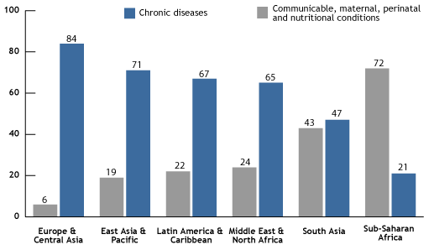

**Figure 1**

|  |  |
| --- | --- |
| The application of ML in disease prediction is not only valuable for individual patient care but also for healthcare systems as a whole. With rising healthcare costs and an aging population, predictive models can help identify at-risk individuals, enabling preventive measures and targeted interventions that reduce the burden on healthcare infrastructure. In this context, ML models serve as decision-support tools for healthcare professionals, improving the accuracy and efficiency of diagnoses and treatment planning.  In this paper, we explore how machine learning algorithms have been employed to predict various diseases, with a focus on heart disease, diabetes, and Parkinson’s. We examine the different ML techniques used, including supervised and unsupervised learning, ensemble methods, and deep learning. Furthermore, we discuss the importance of data preprocessing, feature engineering, and evaluation metrics, which are crucial in developing robust and reliable disease prediction systems.  In this study, we intend to provide a comprehensive overview of the state-of-the-art techniques in disease prediction and highlight future directions and challenges in this field. Finally, the ultimate idea would be to show the level of potential ML has in revolutionizing disease prediction and improving patient care on a global level, by using growing amounts of healthcare data and computational advancements.  **2. Related Projects**  Applications in Healthcare One of the most exciting areas of innovation in modern medicine is machine learning (ML) applications in healthcare, particularly for disease prediction. The global health landscape is characterized by many challenges, including an aging population, a high and increasing incidence of chronic diseases, as well as a want of access to healthcare resources in many areas of the world. In response to these challenges, the application of machine learning technologies has emerged as a highly powerful tool to predict diseases early, assist in diagnosis, and personalize treatment. The ability to predict diseases before symptoms manifest can create transformative effects, such as potential preventative measures, reduced healthcare costs, and improved patient outcomes.  Machine learning techniques are particularly well-suited to identify patterns in big and complex datasets. It includes clinical records, lab results, medical images, genetic data, and lifestyle information-all of which are very well worthwhile to understand about one's health. Using these sources of data, ML models will learn to predict the probability of a patient developing a particular condition sometimes years before that appears clinically. For diseases like heart disease, diabetes, several different cancers, and neurodegenerative disorders such as Alzheimer's, early intervention through predictive modelling can significantly impact survival, improve quality of life, and long-term health outcome. | This is also a key advantage of ML for disease prediction, as it can process and deal with diverging data that are high in dimension, often beyond the capacities of conventional statistical methods or even human expertise. For example, deep learning models can recognize early symptoms of cancer in medical images, while ensemble techniques like random forests or gradient boosting can be used to combine multiple variables from EHRs to predict the likelihood of conditions such as heart attacks or strokes. The predictive models can further assimilate genetic propensities, lifestyle choices, and environmental factors, thus providing a more personalized approach to healthcare.  Despite obvious potential, several challenges persist in the integration of ML models into clinical practice. Data quality and availability pose major challenges in the integration of ML models into clinical practice. Healthcare data are typically noisy, incomplete, and inconsistent. Missing values, outliers, and imbalances in class distributions (e.g., few patients with rare diseases) can significantly affect the performance of ML models. Data privacy and security issues, especially when the data handled is about health, become a challenging factor for the use of such data in model training.  One more bottleneck of ML models relates to their interpretability. Although advanced models, such as deep learning, achieve high accuracy, "black box" is the appropriate term for describing this kind of model-that is, someone cannot understand how a deep learning model makes decisions. The growing importance of this domain can be said to be directly proportional to its ability to develop medical applications that do not require explanations for such critical, life-altering decisions. Therefore, basic research into XAI methods to make ML models transparent is critical for the widespread adoption of these technologies in healthcare.  Healthcare professionals are overwhelmed with work; adding new technologies should improve efficiency while also being practical and usable. Proper collaboration between data scientists, clinicians, and healthcare administrators assures that ML tools are designed and implemented in ways that improve, rather than disrupt, patient care.  At the conclusion of this paper, we intend to give an all-encompassing view of the current landscape of machine learning in disease prediction, focusing on the theoretical and practical issues. We will identify key areas for future research and development, ensuring that ML-driven solutions can be safely, effectively, and ethically deployed in healthcare settings around the world. The main objective of the book is to illustrate how ML can empower clinicians, patients, and healthcare systems with better health outcomes through disease prediction and management strategies that are both timely and accurate, and individualized. |

|  |  |
| --- | --- |
| **3. Proposed Model**  In the proposed model there are three machine learning algorithms Support Vector Machine (SVM), Logistic Regression, Decision Tree are used these algorithms come under supervised learning the architecture and the structure of the work has been shown in fig 2. First our dataset is going to load then the data preprocessing is done split the data set into three parts train, test and valid every part have two components each component contain equal data first component have Feature data and the other component have the Targeted data after successful data preprocessing, then above three algorithms have been applied one by one to the model then the prediction whether the person have health disease or not lastly we compare all the result generated by various applied algorithm is done.  *3.1 Collection and pre-processing of the data*  The dataset that is used in this project to train the model has almost 2000 rows of data. It gives approximately around 80 percent accuracy in identifying the person have health disease. | *3.2 Training Testing and Validation*  The dataset we have used has been divided into 75-15-10 ratio for training testing and validation purposes. Our model is trained on the 75 percent of the total data set and after the training is done the testing is done on the 10 percent data and we check the validation of our model through validation data set and perform operations on that this is the standard deviation of the dataset.  *3.3 Machine Learning*  Machine learning algorithms are being used in this day and age to train any kind of model and give us predictions. We use the supervised learning approach for detecting any health disease. |

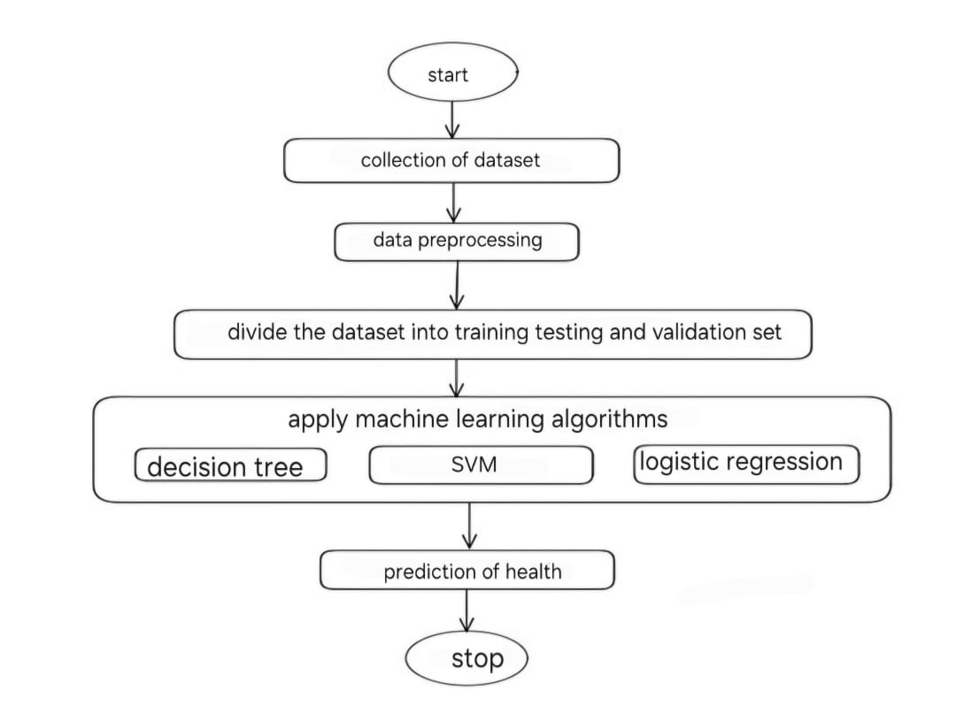

**Figure 2**

|  |  |
| --- | --- |
| *3.3.1 Logistic Regression*  Logistic regression is a supervised machine learning algorithm that accomplishes binary classification tasks by predicting the probability of an outcome, event, or observation. The model delivers a binary or dichotomous outcome limited to two possible outcomes: yes/no, 0/1, or true/false.  With the help of a logistic model, medical practitioners can determine the relationship between variables such as the weight, exercise, etc., of an individual and use it to predict whether the person will suffer from a heart attack or any other medical complication.    Sigmoid function which is basically a mathematical function used in machine learning. Where probability estimation is carried out. $$σ\left(x\right) = \frac{1}{1+e^{-1}}$$ such that, $0≤σ(x)≤1$ Advantages of Logistic Regression:   * Simplicity and Interpretability * Efficient and Fast * Works Well with Linearly Separable Data   Disadvantages of Logistic Regression:   * Limited to Linear Relationships * Sensitive to Outliers * Poor Performance on Complex Datasets   *3.3.2 Support Vector Machines (SVM)*  A support vector machine (SVM) is defined as a machine learning algorithm that uses supervised learning models to solve complex classification, regression, and outlier detection problems by performing optimal data transformations that determine boundaries between data points based on predefined classes, labels, or outputs. This article explains the fundamentals of SVMs, their working, types, and a few real-world examples.  A support vector machine (SVM) is a machine learning algorithm that uses supervised learning models to solve complex classification, regression, and outlier detection problems by performing optimal data transformations that determine boundaries | between data points based on predefined classes, labels, or outputs.  SVMs Optimize Margin Between Support Vectors or Classes  Advantages of SVM:   * Effective in High-Dimensional Spaces * Robust to Overfitting   Disadvantages of SVM:   * Computationally Expensive * Memory Intensive * Binary Classification   *3.3.3 Decision Tree*  A decision tree is a non-parametric supervised learning algorithm, which is utilized for both classification and regression tasks. It has a hierarchical, tree structure, which consists of a root node, branches, internal nodes and leaf nodes.  A decision tree splits the data at each internal node based on certain features. The objective is to divide the dataset into smaller subsets so that each subset (or leaf node) has a higher purity (i.e., it consists mostly of data points from a single class, for classification, or with similar target values, for regression).  Example of a decision tree |
|  |  |

|  |  |
| --- | --- |
| such that,   * p+ is the probability of positive class * p– is the probability of negative class * S is the subset of the training example   Advantages of Decision Trees:   * Easy to Understand and Interpret * Non-linear Relationships * Works Well with Missing Values   Disadvantages of Decision Trees:   * Overfitting * Instability * Bias Toward Features with More Categories   **4. Result and Discussion**  This model gives us a good accuracy in detecting any health disease. The machine learning algorithms are being used in the proposed work because of the classification of the dataset very efficiently. Logistic Regression is widely used for binary classification tasks like predicting the presence or absence of a disease. Support Vector Machines giving high accuracy and precision, especially for binary classification tasks. However, it can be computationally expensive. Decision Tree offers good interpretability, but it is prone to overfitting if the tree is too deep.  Receiver operating characteristics (ROC) curves for logistic regression...  | Download Scientific Diagram  **Figure 3**  (ROC curve of Logistic Regression) | ROC curves for SVM, PLS, and k-NN models. Shown are ROC curves for SVM,...  | Download Scientific Diagram  **Figure 4**  (ROC curve of Support Vector Machines)  ROC curve for Decision Tree classifier C. Malware Classification... |  Download Scientific Diagram  **Figure 5**  (ROC curve of Decision Tree) |

|  |  |
| --- | --- |
| **5. Conclusion and Future Work**  In this paper we have used supervised machine learning algorithms to be more specific we have used Logistic Regression, Support Vector Machines and Decision Tree for the prediction of any health disease in real time and then we have compared the performance of all the algorithms. We have divided our data set into two parts 80 percent for training the model and the rest is for testing the model.  The future scope for this is to develop another machine model that can give the immediate emergency response after any type of health disease so that we can integrate the two models and save many lives in the process.  **ACKNOWLEDGEMENT**  I would like to express my sincere gratitude to professor DR. Amit Gupta Sir, whose guidance, expertise and encouragement were invaluable throughout my research on Multiple Health Disease prediction. His insights into data analysis, model selection and real-world applications have significantly enhanced the quality and depth of this study. I am deeply appreciative of his support, patience and commitment to my academic growth, which motivated me to overcome challenges and achieve my research goals. This paper would not have been possible without his mentorship and dedication.  **REFRENCES**  [1] Kaur, M., & Arora, A. (2020). Multiple disease prediction using machine learning techniques. *International Journal of Computer Applications*, 177(40), 26-31.  [2] Chaurasia, V., & Pal, S. (2018). A survey of classification techniques in medical disease prediction. *International Journal of Computer Science and Information Technologies*, 9(1), 1-5.  [3] Sharma, A., & Singh, P. (2021). Predicting heart disease using machine learning techniques. *Procedia Computer Science*, 192, 1787-1793.  [4] Basu, S., & Wang, L. (2020). A comprehensive survey of machine learning techniques in medical diagnosis. *Healthcare Informatics Research*, 26(3), 179-188.  [5] R. K. Sharma, D. K. Sharma, and S. M. Patel, "Big Data Analytics in Healthcare: A Review of Disease Prediction Models," Journal of Healthcare Engineering, vol. 2020, pp. 1-10, 2020.  [6] P. G. A. M. M. Abood, "Deep Learning Models for Disease Diagnosis: A Survey," Journal of Artificial Intelligence in Medicine, vol. 56, no. 3, pp. 103-116, 2020. |  |